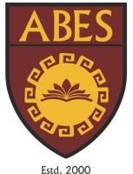ABES ENGINEERING COLLEGE CCPD TECH DEPARTMENT PROJECT

**Project Id**: IT/A/001

**Project Title**: ABES Engineering College Utsav Homepage

**Project Description** : This project is to create a homepage for the ABES Engineering College Utsav (a cultural fest). The homepage should feature sections for event schedules, performer lineups, and registration forms. Although it is a dummy project, it must simulate a real-world event website for a cultural fest.

**Key Features to Implement:**

1. Header with logo and navigation
2. Event Information Carousel
3. Schedule Section
4. Registration Form
5. Sponsor Logos in the footer
6. Responsiveness(optional)

**Timeline**: 2 Week(s)

**Technology needs to used:**

|  |  |  |  |  |  |  |  |  |  |
| --- | --- | --- | --- | --- | --- | --- | --- | --- | --- |
| S. No | **Html 5** | | | **CSS3** | | | **Java Script** | | |
| 1 | Div/span | Audio/video | img | Display/position | flex | Pseudo- class | map | Form  validation | Arrow |